SQL Book

# How To Use All The Different JOINs in SQL | by Connor Finnegan ...

# What is a database?

In simple terms, a database is a collection of data stored in a computer system. Here are other definitions of a database:  
   
According to **Wikipedia**:

A database is an organized collection of data, generally stored and accessed electronically from a computer system.

According to **Oracle**:

A database is an organized collection of structured information, or data, typically stored electronically in a computer system.

People use data and databases with or without awareness in their daily life activities.  
  
**How are databases used in the real-world?**

Databases are almost everywhere. Your bank, your grocery store, an app on your cellphone, websites all use databases to keep track of your data. When you access a website, the website starts to collect your data (e.g. accessing date and time, your location, your browser info) and store it in its database.

Let's take another example. When you order a product on a commercial website, your order is stored in a database. You withdrew money from your bank account. Your bank stores this transaction in the database. Social media platforms such as Facebook, Instagram, Twitter use databases to store data like members, their friends, member activities, messages, advertisements, etc.

(Note: In diagrams, databases are represented as a cylinder shape.)

A database is typically controlled by a **database management system (DBMS)**. Data and DBMS along with the applications that are associated with them are called a database system, often shortened to just database.

Q: What is a Database?  
A: A database is an organized collection of data, generally stored and accessed electronically from a computer system. In simple terms, a database is a collection of data stored in a computer system. When you order a product on a commercial website, your order is stored in a database. You withdrew money from your bank account. Your bank stores this transaction in the database. Social media platforms such as Facebook, Instagram, Twitter use databases to store data like members, their friends, member activities, messages, advertisements, etc.

The information inside the database is grouped into tables. A table in a database is called a *database table*. Tables are the basic unit of data storage in databases. We talked about the definition of the database in the previous lesson. We used the term **structured data.**Structured data heremeans table. A table consists of columns and rows. You may think of it as an Excel or Google spreadsheet. Although there are similarities between the database table and Excel/Google spreadsheet, they are different things. We won't get into details here.

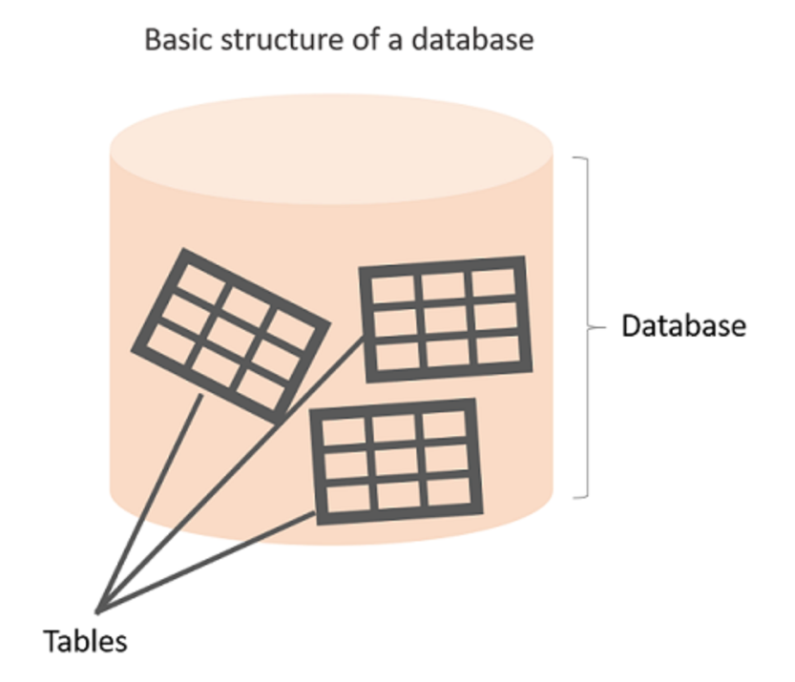

## Anatomy of a Table

A table is made up of columns and rows. A column is a piece of data stored by the table. A row is a single set of columns that describe the attributes of a single thing. Columns should have a unique name. Columns and rows together make up a table.

**💡Tips:**

* In database world;
* A column is also called a field or attribute,
* A row is also called a record or a tuple,
* A table is also called a relation.

Column header names are written in lowercase, and there shouldn't be any space in a single name. Put an underscore between them. For instance, don't write "*last name"* as a header name, instead, write "*last\_name"*. Table names are also written in lowercase and without space (*employees*, *customers*, etc.)

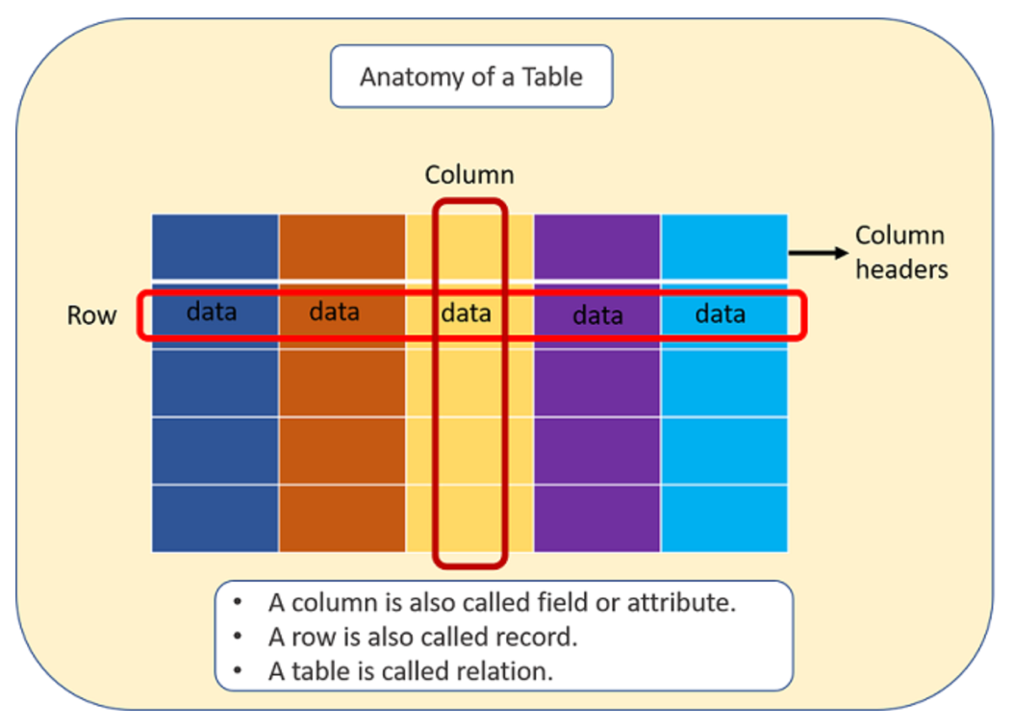

A database can consist of one or more tables. In most cases, more than one table. Each table has a unique name, such as employees, departments, or customers, etc.

##### Example

Let's take the case of a company database. Suppose that it has two tables. One is employees, and other is departments. Take a closer look at the employees table below. Here is the breakdown of the table.

* Table's name is *employees.*
* The table has seven columns (aka, fields or attributes)
* The table has ten rows (aka, records or tuples)
* Table's column header names are:  emp\_id, first\_name, last\_name, salary, job\_title, gender, hire\_date
* Inside the employees' table, there is data about each employee in the company

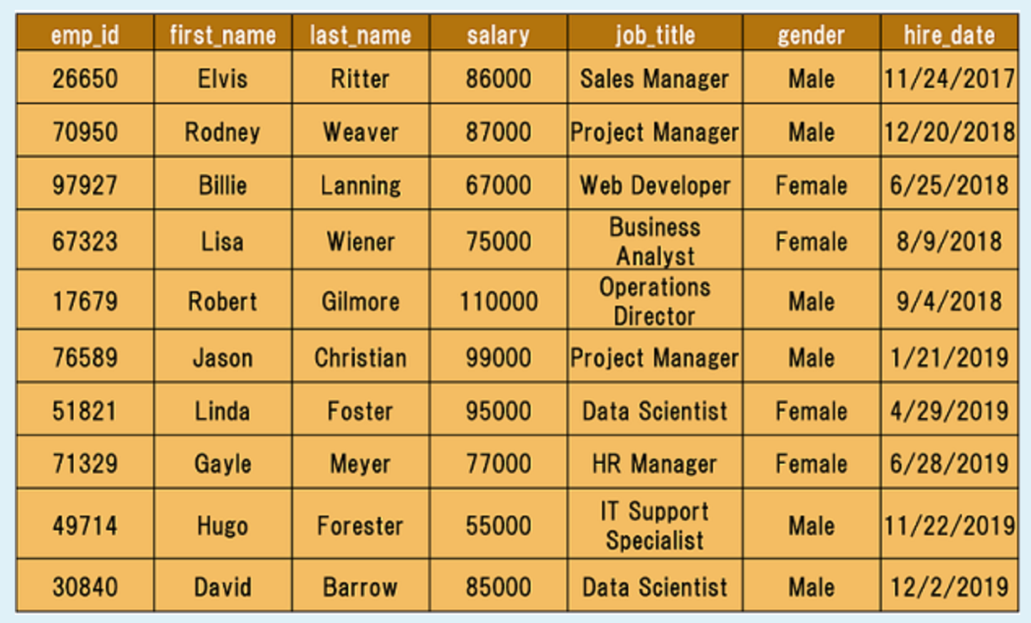

Q: What is a table, column and row?  
A: A table is an organized collection of data stored in the form of columns and rows. Columns can be categorized as vertical and rows as horizontal. The columns in a table are called fields while the rows can be referred to as records.

## Type of Databases

Typically, there are two main database storage types:

* **Relational Database - SQL**
* **Non-Relational Database – NoSQL**

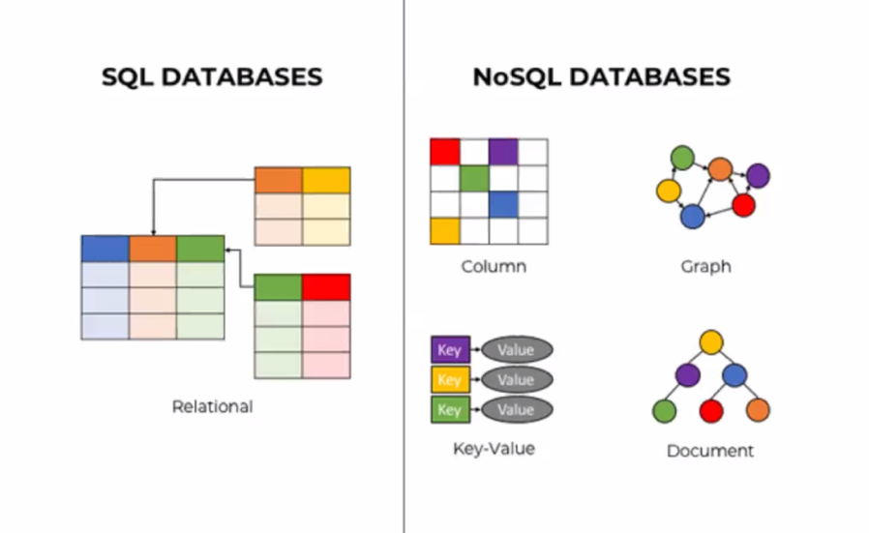

### Relational Database

 is a type of database that stores and provides access to data points that are related to one another.

Relational databases are based on the relational model, an intuitive, straightforward way of representing data in tables. In a relational database, each row in the table is a record with a unique ID called the key. The columns of the table hold attributes of the data, and each record usually has a value for each attribute, making it easy to establish the relationships among data points.

Actually, the term "relational database" was invented by E. F. Codd at IBM in 1970. Codd introduced the term in his research paper "A Relational Model of Data for Large Shared Data Banks". In this paper and later papers, he defined what he meant by "relational". One well-known definition of what constitutes a relational database system is composed of Codd's 12 rules. However, no commercial implementations of the relational model conform to all of Codd's rules, so the term has gradually come to describe a broader class of database systems, which at a minimum:

* Present the data to the user as relations (a presentation in tabular form, i.e. as a *collection* of tables with each table consisting of a set of rows and columns);
* Provide relational operators to manipulate the data in tabular form.

A software system used to maintain relational databases is called a *Relational Database Management System (RDBMS).*  Here are some examples of RDBMS:

* Amazon Aurora
* Amazon RDS
* Microsoft SQL Server
* Oracle Database
* MySQL
* IBM DB2
* Maria DB
* PostgreSQL
* SQLite

SQL (stands for Structured Query Language) is accepted as the standard Relational Database Management System (RDBMS) language. So we usually prefer to call Relational Database as SQL and Non-Relational database as NoSQL.

Until now in the course, what we've shown you some relational database features (structured data, tables, rows, columns, etc). Of course, there are more than those features coming in the upcoming parts of the course. During the pre-class phase of the SQL course, we will use SQLite as an RDBMS tool.

**💡Tips:**

* SQLite is a relational database management system contained in a C library. In contrast to many other database management systems, SQLite is not a client–server database engine. Rather, it is embedded into the end program. (Wikipedia)

Now, it's time to communicate with our database with SQL.

# Getting Started with Databases

## Structured Query Language (SQL)

SQL stands for Structured Query Language and used to communicate with relational databases. SQL is a declarative language, not a procedural language. You write a single SQL declaration and hand it to the DBMS. The DBMS then executes internal code, which is hidden from us.

* Declarative paradigm is where you say what you want without having to say how to do it. With procedural paradigm (used in JAVA, C), you have to specify exact steps to get the result. SQL is declarative than procedural since the queries don't specify steps to produce the result.
* SQL in it's purest form is not a programming language, but a query language. Because, it needs to be able to perform loops and control structures. However, with some extensions, SQL can have looping and control structures but they exist outside or rather as an appendage to the original SQL spec. In this manner, some argue that SQL is a programming language.

Most commercial database systems employ the SQL language.With SQL, you can access or manipulate data stored in the database. There are different types of access. These are:

* Retrieval of data from the database
* Insertion of new data into the database
* Updating the data in the database
* Deletion of data from the database

Besides, you can create new databases and tables using SQL.

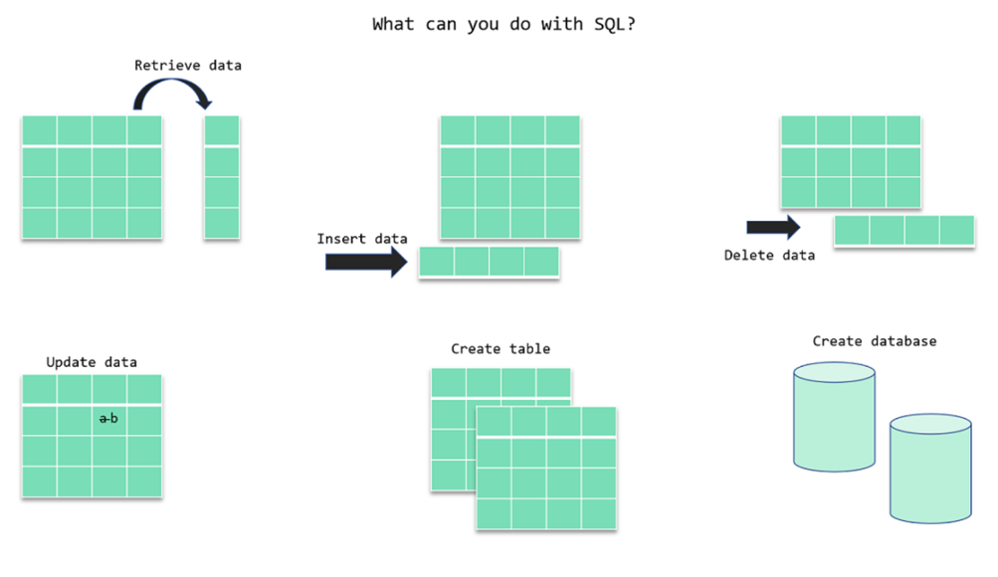

A **query** is a statement asking for the retrieval of information from the database.

Q: What is SQL?  
A: SQL stands for Structured Query Language and used to communicate with a database. With SQL, you can access or manipulate data stored in the database.

## SQL Language Elements

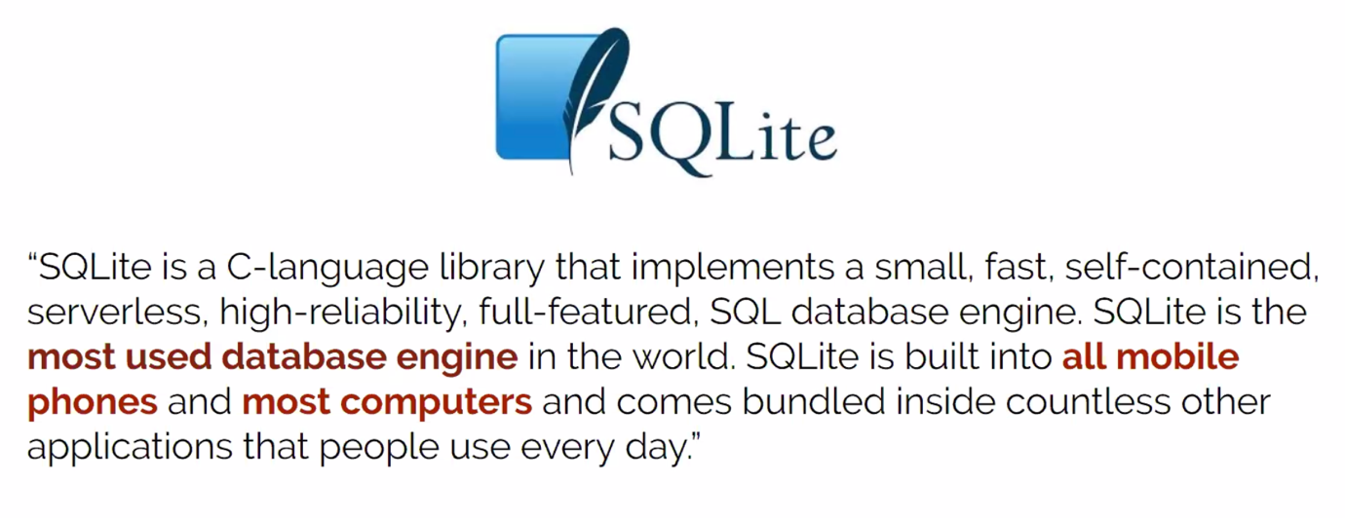

SQL language structure is easy to understand. It looks like plain English. Here is an example SQL statement:

SELECT first\_name FROM employees;

The whole command SELECT first\_name FROM employees; is called **statement.**

Let's breakdown of this statement. Herein SELECT, FROM words are keywords. They are special commands for SQL. first\_name, employees are identifiers. SQL statements end with a semicolon (;).  SQL Language Elements is also called SQL Syntax.

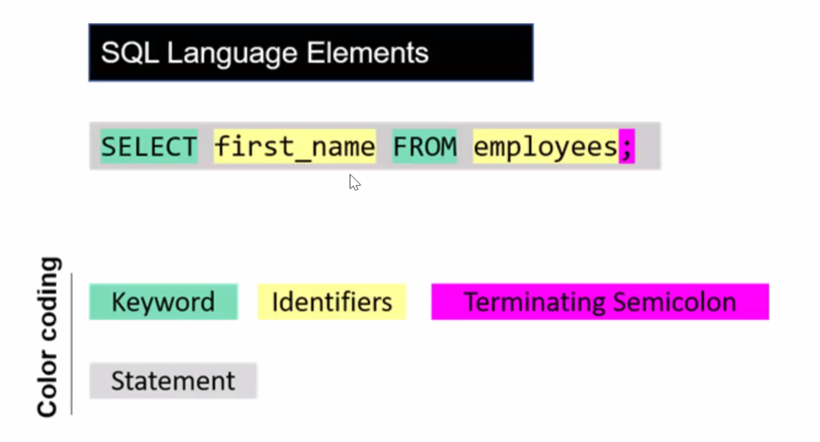

There are other SQL elements which we will cover later in the course. In the next part, we will introduce you SELECT statement in detail. We will learn the syntax and start to write our commands.

## SELECT Statement

* The SELECT statement is used to select data from a database.
* You can retrieve rows from the columns of the table by using this statement.
* SELECT statement is used with FROM keyword.
* The syntax of the SELECT statement can be seen below.

SELECT column\_name(s) FROM table\_name;

As you see, SELECT and FROM words were written in uppercase, and the query ends with a semicolon. Is this usage example a syntax rule? In SQL syntax;

* SQL statements start with a keyword like SELECT, INSERT, UPDATE, DELETE, etc. and all the statements end with a semicolon (;).
* The semicolon at the end indicates that the statement is completed and ready to be executed.
* SQL is also case insensitive, which means you can use both SELECT and select in your query. They mean the same thing for SQL.
* Writing SQL commands in the upper-case is the most common and preferred style. But, you can write the same query in both ways as below:

|  |
| --- |
| select column\_name(s) from table\_name;  SELECT COLUMN\_NAME(s) FROM TABLE\_NAME; |

White spaces and empty lines are ignored in SQL. So, the below query is correct by all means.

|  |
| --- |
| SELECT column\_name(s)  FROM table\_name; |

**Tip:** To maintain your query clean and more readable, it's not recommended to use unnecessary empty lines and white spaces .

### Selecting Multiple Columns

SELECT column1, column2 FROM table1;

### Selecting All Columns

SELECT \* FROM table1;

### DISTINCT Clause

You will focus on the SELECT DISTINCT statement in SQL. Columns in the tables may often contain some duplicate values, but you may only need the distinct values as a result. Here comes the SELECT statement with the DISTINCT clause.

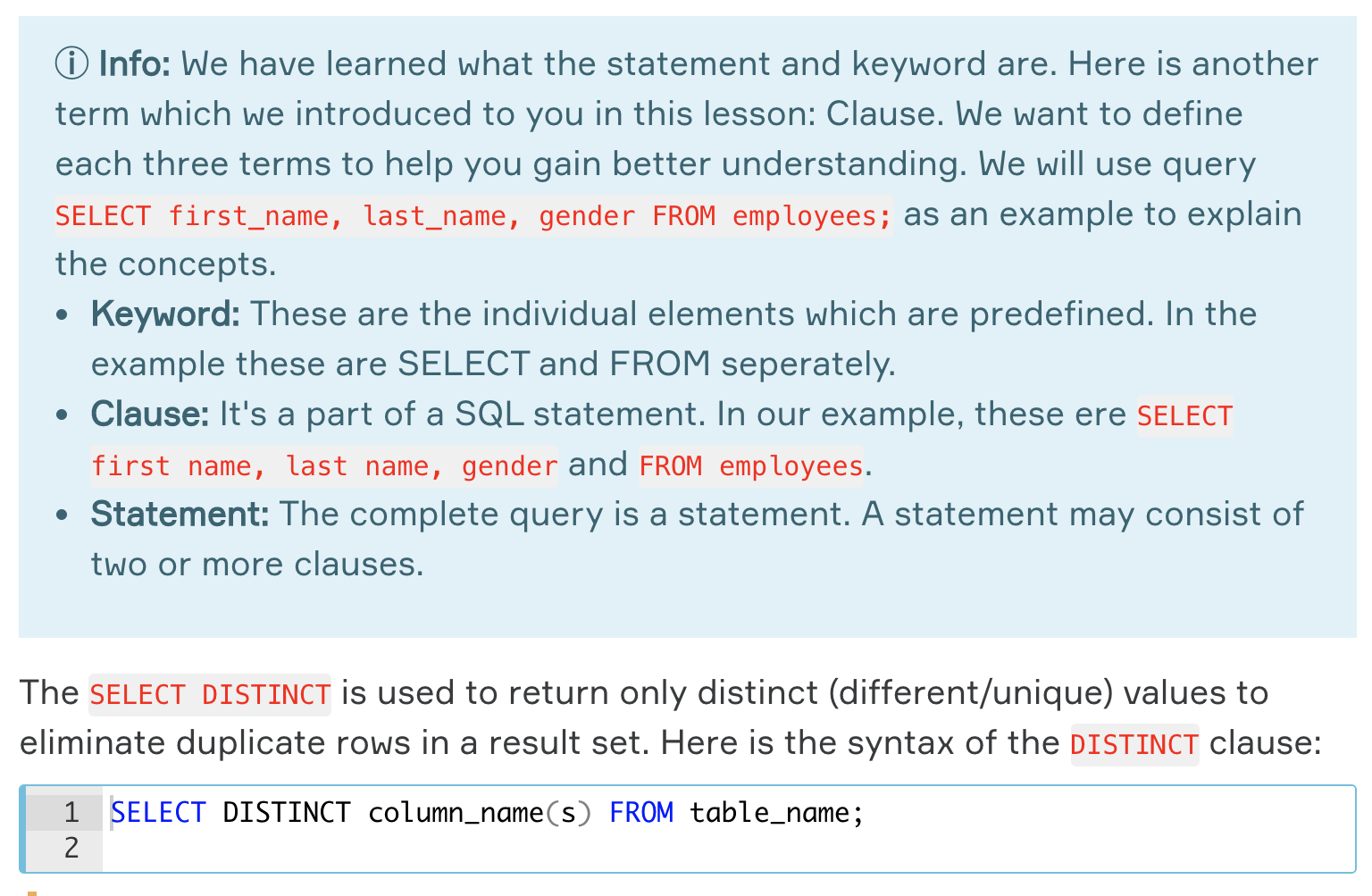If there is no duplicated rows 🡪 SELECT and SELECT DISTINCT gives the same result

Q: What are some common clauses used with SELECT query in SQL?  
A: WHERE clause, ORDER BY clause, GROUP BY clause and HAVING clause.

### WHERE Clause

SELECT column\_name(s) FROM table\_name WHERE condition(s);

| **Operator** | **Description** |
| --- | --- |
| = | Equal to |
| > | Greater than |
| < | Less than |
| >= | Greater than or equal |
| <= | Less than or equal |
| <> | Not equal. This operator may be written as != in some versions of SQL |
| BETWEEN | Test if a value is between a certain range of values |
| LIKE | Determine if a character string matches a predefined pattern |
| IN | Test whether or a value matches any value in a list |

|  |
| --- |
| SELECT \* FROM student\_table WHERE grade > 70; |
| SELECT \* FROM student\_table WHERE lesson = "Mathematics"; |
| SELECT \* FROM student\_table WHERE lesson = "Mathematics" AND grade > 70; |

### LIMIT Clause

The LIMIT clause is used to filter records. It constrains the number of rows returned by a query.

Assume that your query returns one thousand rows. But you only want to see the first 10 rows in the result set. In such cases, we use LIMIT clause to obtain the desired output.

SELECT column\_name(s) FROM table\_name LIMIT number\_rows;

|  |
| --- |
| SELECT \* FROM student\_table LIMIT 3; |
| SELECT \* FROM student\_table WHERE grade > 70 LIMIT 2; |

### ORDER BY Clause

SELECT statement returns records in an unspecified order. In case you want to retrieve data in alphabetical or numeric order, we use ORDER BY keyword.

The ORDER BY keyword sorts the result-set in descending or ascending order.

By default ORDER BY keyword sorts the records in ascending order. Use the keyword DESC to sort the records in descending order. You can also use ASC to sort the data in ascending order.

SELECT column\_name(s) FROM table\_name ORDER BY column\_name(s) ASC|DESC;

Herein **"|"** symbol means "use either ASC or DESC". If you don't use any of them, the default value is ASC (ascending order).

|  |
| --- |
| SELECT \* FROM employees ORDER BY first\_name ASC; |

You could write the query which returns the same result table as below. Since ASC is the default order value in case you don't specify any ascending or descending order, both queries will yield the same result.

|  |
| --- |
| SELECT \* FROM employees ORDER BY gender DESC, first\_name ASC;  ## We do not write ORDER BY two or more times |
| SELECT \*  FROM employees  WHERE salary > 80000  ORDER BY first\_name DESC; |

We first returned the employees whose salary is higher than $80,000. Next, we sorted this by the first names in descending order.

### AND, OR & NOT Operators

|  |
| --- |
| SELECT \*FROM employeesWHERE job\_title = 'Data Scientist' AND gender = 'Male'; |
| SELECT \*FROM employeesWHERE NOT gender = 'Female'; |

### BETWEEN Operator

The BETWEEN operator is used for comparison in WHERE clauses. It's a comparison operator. You can use it to test if a value is in a range of values. If the value is in the specified range, the query returns all records fallen within that range.

WHERE test\_expression BETWEEN low\_expression AND high\_expression

WHERE test\_expression >= low\_expression AND test\_expression <= high\_expression

**☝ Important:** The **BETWEEN** operator is inclusive. To specify an exclusive range, use the greater than (>) and less than operators (<).

|  |
| --- |
| SELECT \*FROM employeesWHERE salary BETWEEN 80000 AND 90000; |
| SELECT \*FROM employeesWHERE salary >= 80000 AND salary <= 90000; |

### SELECT \* FROM employees

### WHERE hire\_date BETWEEN '2018-06-01' AND '2019-03-31'

### ORDER BY hire\_date;

### 

### NOT BETWEEN Operator

WHERE test\_expression NOT BETWEEN low\_expression AND high\_expression

|  |
| --- |
| SELECT \*FROM employeesWHERE salary NOT BETWEEN 80000 AND 90000; |
| SELECT \*FROM employeesWHERE salary < 80000 OR salary > 90000; |

### IN Operator

The IN operator is used to determine whether a value matches any value in a list. We use IN operator with WHERE clause.

WHERE column\_name IN (value\_list)

|  |
| --- |
| Suppose that you are building a team in your company. The team is comprised of Data Scientist and Business Analyst. You need to search the employee table to find the right candidates for your team. You may come up with this query: |
| SELECT \*  FROM employees  WHERE job\_title = 'Data Scientist'  OR  job\_title = 'Business Analyst'; |
| SELECT \*  FROM employees  WHERE job\_title IN ('Data Scientist', 'Business Analyst'); |

|  |
| --- |
| SELECT \*FROM employeesWHERE job\_title IN ('Data Scientist', 'Business Analyst', 'Project Manager', 'Web Developer'); |

**💡 Tip:** If you have a query in which you use many OR operators, consider using the IN operator instead. This will make your query more readable.

### NOT IN Operator

|  |
| --- |
| SELECT \*FROM employeesWHERE job\_titleNOT IN ('Operations Director', 'HR Manager', 'Sales Manager'); |

|  |
| --- |
| SELECT \*FROM student\_infoWHERE stateIN ('Virginia') AND fieldIN ('Data Analysis', 'Data Science', 'DevOps'); |

### LIKE Operator

There are some cases where you don't know exactly the complete value you query. For instance, consider that you're trying to recall a student's county info from our student\_info table. You know that the county's name starts with 'Wo'. In such cases, we use LIKE operator.  We combine LIKE operator with WHERE clause.

The general syntax is:

SELECT column\_name(s)

FROM table\_name

WHERE column\_1 LIKE pattern;

After LIKE keyword, we construct a pattern. SQL provides two special characters for constructing patterns. These are also called wildcards.

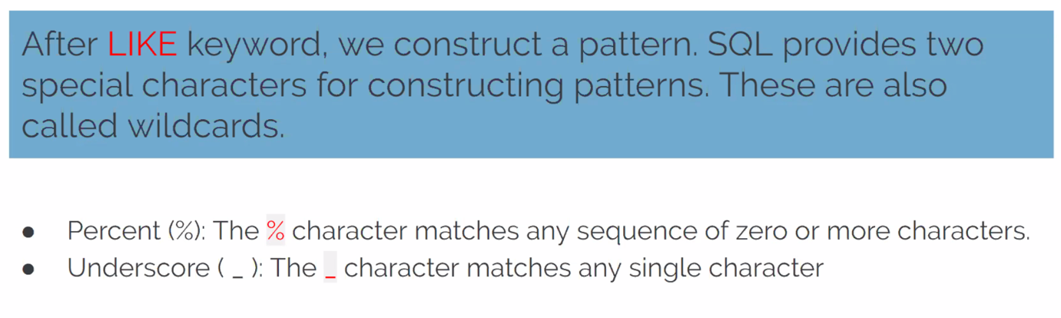

Patterns are case insensitive. Uppercase characters do match lowercase characters or vice versa. Let's show pattern matching in the following examples. You will find some pattern examples which can be used after the LIKE operator. Patterns are written in single quotes.

* 'Out%' pattern matches any string beginning with "Out" such as "Outro".
* 's%' pattern matches any string that starts with "s" such as "silk", "soup", etc.
* '%per%' pattern matches any string containing "per" such as "percentile" and "peeper".
* 's\_n' pattern matches "son", "sun", etc.
* '\_\_te' pattern matches "mate", "Kate", "kate", etc.

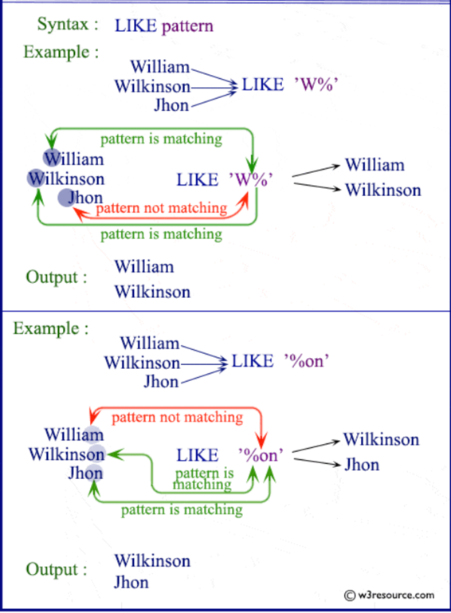

Now. Let's try to find a solution to our question at the beginning. We were trying to recall the county name which starts with "Wo". Since we don't know how many letters coming after "Wo", it's a good idea to use % wildcard here. Here is the pattern 'Wo%'.

|  |
| --- |
| SELECT \*  FROM student\_info  WHERE county LIKE 'Wo%'; |

There are 12 students whose field is Back-End Developer or Front-End Developer. We could write the pattern as '%Developer%'. This also returns the same result table. There is no character coming after the word "Developer". But remember % wildcard also matches zero characters.

In the previous part, we said that LIKE operator is case-insensitive. That means instead of '%Developer', we can write '%developer', '%DEVELOPER' even '%DEveloper'. All those patterns will match "Back-End Developer" or "Front-End Developer"

\_\_\_\_\_\_\_\_

The underscore \_ wildcard matches a single character. Think of it as representing a single character. For instance, the following query finds the employee whose first\_name is "Elvis".

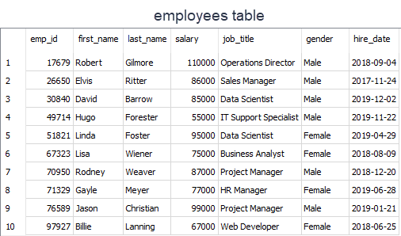

|  |
| --- |
| SELECT first\_name  FROM employees  WHERE first\_name LIKE 'El\_is'; |
| first\_name  ----------  Elvis |

The \_ wildcard in the pattern matches "v" letter in "El**v**is" in the first name column.

Which first name the 'Li\_\_a' pattern will match in the first name column? The answer is "Linda". Note that there are two underscore characters in the 'Li\_\_a' pattern. Thus, those will match "nd" letters in "Li**nd**a" in the first name column.

# Aggregate Functions and JOINs

Aggregate functions are functions that take a collection of values as input and return a single value. SQL has five built-in aggregate functions:

* COUNT (Count)
* MIN (Minimum)
* MAX (Maximum)
* SUM (Total)
* AVG (Average)

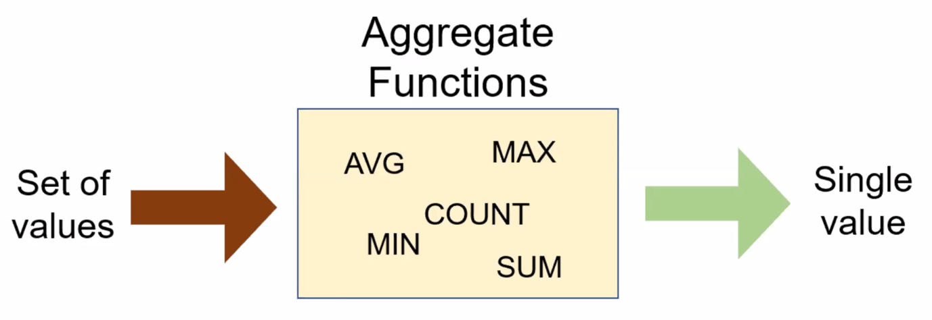

* SUM and AVG functions must take only numeric values as input.
* However, the other functions (MIN, MAX, COUNT) may take non-numeric values (strings, date, etc.) as input other than numeric values.

Before we dive into the aggregate functions, we should learn an important concept which is NULL.

NULL means no data and is a special value. It shows us that a piece of information is unknown or missing or not applicable. For instance, let's assume that we have a song database and we don't know the writers of some of them. We don't have that information. So, to store these unknown songwriters in a database table, we must use NULL. If a table has NULL value, then it will be displayed as NULL.

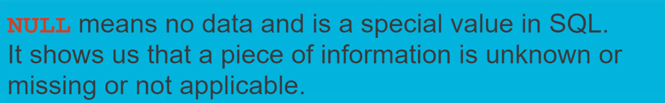

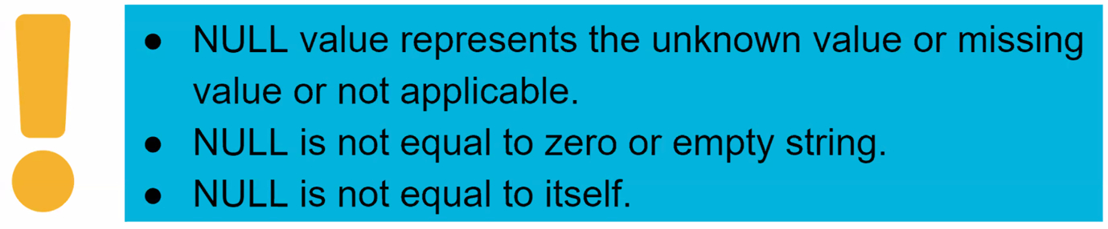

It's important to understand what nulls mean and to know how to work with them. They are often ignored in our aggregation functions.

Q: What is an aggregate function?  
A: An aggregate function performs operations on a collection of values to return a single scalar value. Aggregate functions are often used with the GROUP BY and HAVING clauses of the SELECT statement.

## COUNT

We use COUNT function to count the numbers of records (a.k.a row) in a table. Here is the syntax of the COUNT function:

SELECT COUNT(column\_name)

FROM table\_name;

Use COUNT keyword immediately after SELECT keyword. Then specify the column on which you want to operate.

|  |
| --- |
| SELECT COUNT(first\_name)  FROM student\_info; |
| COUNT(first\_name)  -----------------  32 |

32 students enrolled in the courses.   
This query counts all the first names in the student\_info table. You would reach the same result if you used COUNT(last\_name).

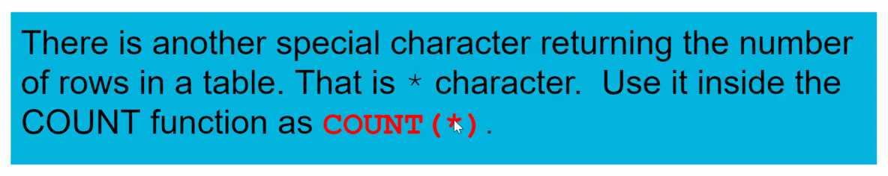

If you notice that the header of the output query is displayed as COUNT(first\_name). However, we can customize the header using AS keyword. AS is used to rename a column or table with an alias.

This is the syntax:  
 SELECT column\_name AS alias\_name

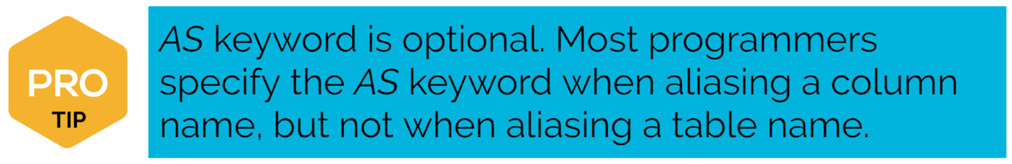

Let's rewrite the query above:

|  |
| --- |
| SELECT COUNT(first\_name) AS count\_of\_students  FROM student\_info; |
| count\_of\_students  -----------------  32 |

As you see that what you wrote after AS keyword is displayed as a column header. 

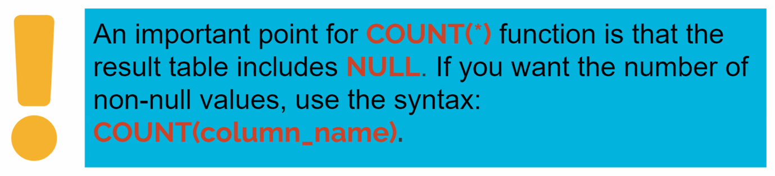

## COUNT DISTINCT

In some cases, we may want unique values. For instance, let's find how many different fields there are in the student\_info table.

First, write this query:

|  |
| --- |
| SELECT COUNT(field) AS count\_of\_field  FROM student\_info; |
| count\_of\_field  --------------  32 |

As you see that there are 32 fields. But, is that the correct number? Absolutely no. There are duplicate values. For instance, there is more than one student who enrolled in the course in the field of *Data Science*.

COUNT(field) counts the duplicate rows as separate rows. So, we need to use COUNT(DISTINCT column\_name) function here.

|  |
| --- |
| SELECT COUNT(DISTINCT field) AS count\_of\_field  FROM student\_info; |
| count\_of\_field  --------------  6 |

Actually there are 6 unique or distinct fields in which students may enroll. COUNT(DISTINCT field) returns the number of unique and non-null values in column *field*.

We can also combine COUNT(DISTINCT) or COUNT() functions with WHERE clause.

For instance, display the number of students from Virginia.

|  |
| --- |
| SELECT COUNT(\*) AS count\_of\_students  FROM student\_info  WHERE state = 'Virginia'; |
| count\_of\_students  -----------------  14 |

## MIN and MAX

MIN function returns the minimum value in the selected column.

The syntax of the MIN function:

SELECT MIN(column\_name)

FROM table\_name;

The MIN function ignores the NULL values. Thus, it retrieves the non-NULL minimum value in the selected column.

|  |
| --- |
| SELECT MIN(salary) AS lowest\_salary  FROM employees; |
| lowest\_salary  -------------  55000 |

We can also combine MIN function with WHERE clause. Let's move the query above to the next level. Display the female employee who gets paid the lowest.

|  |
| --- |
| SELECT MIN(salary) AS lowest\_salary  FROM employees  WHERE gender = 'Female'; |
| lowest\_salary  -------------  67000 |

You can use ORDER BY and LIMIT keywords to get the minimum value in a selected column. This will yield the same result as in the MIN function.  
  
The MIN function can also be used with dates. For instance, display the earliest hired employee's date.

|  |
| --- |
| SELECT MIN(hire\_date) AS earliest\_date  FROM employees; |
| earliest\_date  -------------  2017-11-24 |

## SUM Function

SUM function returns the sum of a numeric column.

The syntax of the SUM function:

SELECT SUM(column\_name)

FROM table\_name;

Now, let's calculate the total amount of the salary of the employees in the company.

|  |
| --- |
| SELECT SUM(salary) AS total\_salary  FROM employees; |
| total\_salary  ------------  836000 |

The amount of the total salary is $836,000. We can breakdown this into categories. For instance, we can find the total amount of salary of female employees.

|  |
| --- |
| SELECT SUM(salary) AS total\_salary  FROM employees  WHERE gender = 'Female' |
| total\_salary  ------------  314000 |

## AVG Function

AVG function calculates the average of a numeric column.

The syntax of the AVG function:

SELECT AVG(column\_name)

FROM table\_name;

|  |
| --- |
| SELECT AVG(salary) AS average\_salary  FROM employees; |
| average\_salary  ------------  83600.0 |

The average salary of the employees is $83,600.  The total amount of the salary is $836,000. Since there are 10 employees, the average salary is $836,000/10 = $83,600. We just proved it.  
  
Now, let's find the average salary amongst male employees.

|  |
| --- |
| SELECT AVG(salary) AS average\_salary  FROM employees  WHERE gender = 'Male'; |
| average\_salary  ------------  87000.0 |

## GROUP BY Clause

There are some cases where we may need to apply the aggregate function not only to a selected group of rows. In the previous parts, we found the total amount of salaries of male and female employees separately.  What if want to show them in the same result table grouped by their gender. In such cases, we use GROUP BY statement.

The GROUP BY clause groups the rows into summary rows. It returns one value for each group and is typically used with aggregate functions (COUNT, MAX, MIN, SUM, AVG).

The syntax is:

SELECT column\_1, aggregate\_function(column\_2)

FROM table\_name

GROUP BY column\_1;

In case a WHERE clause is used, the GROUP BY clause should come after the WHERE clause. We specify the column or a list of comma-separated columns right after the GROUP BY.  Any nonaggregate expression in the SELECT must be included in the GROUP BY clause.

We've mentioned that the GROUP BY clause is often used with aggregate functions. Now, let's see how it is.

**Tips:**

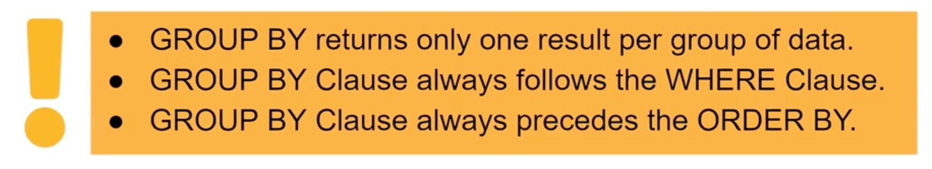

### GROUP BY with COUNT Function

The following statement returns the number of employees per gender.

|  |
| --- |
| SELECT gender, COUNT(gender)  FROM employees  GROUP BY gender; |
| gender COUNT(gender)  ---------- -------------  Female 4  Male 6 |

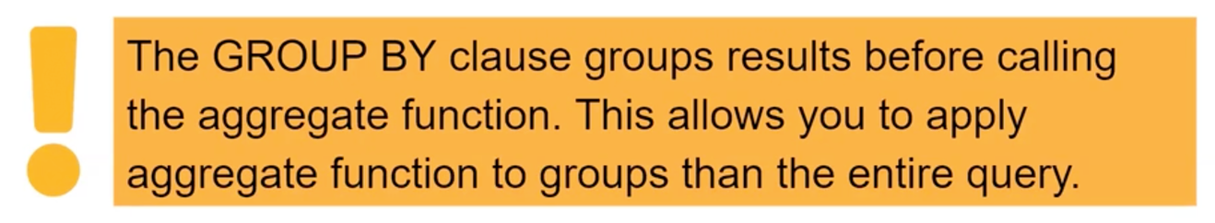

Now, let's write another query. What is the number of employees working as a data scientist? Break down it by gender.

|  |
| --- |
| SELECT gender, COUNT(job\_title)  FROM employees  WHERE job\_title = 'Data Scientist'  GROUP BY gender; |
| gender COUNT(job\_title)  ---------- ----------------  Female 1  Male 1 |

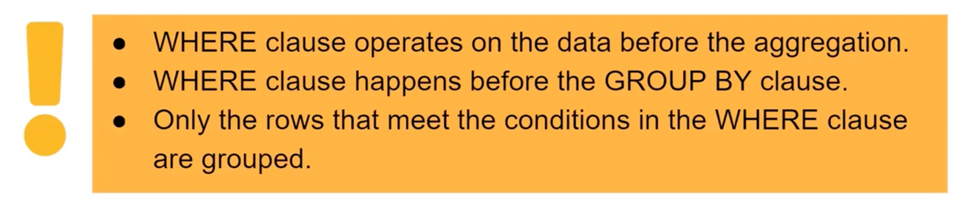

### GROUP BY with MIN&MAX Functions

Let's find the minimum salaries of each gender group using the MIN function.

|  |
| --- |
| SELECT gender, MIN(salary) AS min\_salary  FROM employees  GROUP BY gender; |
| gender min\_salary  ---------- ----------  Female 67000  Male 55000 |

You may also use the ORDER BY clause to sort the salaries in descending or ascending order.  The ORDER BY follows GROUP BY. For instance, sort the maximum salaries for each group in descending order.

|  |
| --- |
| SELECT gender,  MAX(salary) AS max\_salary  FROM employees  GROUP BY gender  ORDER BY max\_salary DESC; |
| gender max\_salary  ---------- ----------  Male 110000  Female 95000 |

**Tip:** When sorting, you can use the alias with ORDER BY clause as we did in the query above (ORDER BY **max\_salary**). You may also use the original aggregate function as ORDER BY **MAX(salary**)

### GROUP BY with SUM&AVG Functions

In the previous part, we have learned how to use MIN and MAX functions with the GROUP BY clause. In this part, we will continue with SUM and AVG functions. Let's go with the same scenario. In this case, we will calculate the total salaries of each group (gender).

|  |
| --- |
| SELECT gender, SUM(salary) AS total\_salary  FROM employees  GROUP BY gender; |
| gender total\_salary  ---------- ------------  Female 314000  Male 522000 |

Similarly, we can find the average salaries of each group using the AVG function.

|  |
| --- |
| SELECT gender, AVG(salary) AS average\_salary  FROM employees  GROUP BY gender; |
| gender average\_salary  ---------- --------------  Female 78500.0  Male 87000.0 |

You may also use the ORDER BY clause to sort the salaries in descending or ascending order. For instance, sort the total salaries for each group in descending order.

|  |
| --- |
| SELECT gender,  SUM(salary) AS total\_salary  FROM employees  GROUP BY gender  ORDER BY total\_salary DESC; |
| gender total\_salary  ---------- ------------  Male 522000  Female 314000 |

## JOIN

A JOIN clause is used to combine two or more tables into a single table. Joins are usually applied based on the keys that define the relationship between those tables or on common fields.

In most cases this joins are created using the primary key of one table and the foreign key of the table we want to join it with.

We've added a new table "departments" to our company database. We have now two tables "employees" and "departments" in the database. Now let's examine those two tables. In the "departments" table, the names of the employees are not written, only the ID numbers of the employees are written.

When looking at the "departments" table, it is not easy to understand which employee is working in which department, since this table does not contain the names of the employees. For this purpose, two tables should be combined and the name and surname of that employee should be found by looking at the "employees" table for each employee ID in the "departments" table. The "emp\_id" is the column that will form the relationship between the two tables above.

### JOIN Types

There are basically five types of JOINs: INNER JOIN, LEFT JOIN, RIGHT JOIN, FULL OUTER JOIN and CROSS JOIN. As a special case, a table can join to itself and this type is called SELF JOIN.

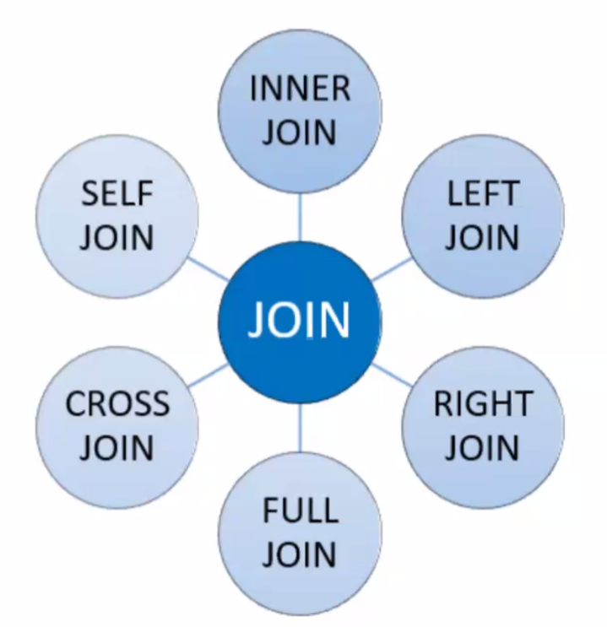

* **INNER JOIN:** Returns the common records in both tables.
* **LEFT JOIN:** Returns all records from the left table and matching records from the right table.
* **RIGHT JOIN:** Returns all records from the right table and matching records from the left table.
* **FULL OUTER JOIN:** Returns all records of both left and right tables.
* **CROSS JOIN:** Returns the Cartesian product of records in joined tables.
* **SELF JOIN:** A join of a table to itself.

We'll focus on INNER join and LEFT join which are commonly used.

Q: What is a Join?  
A: The SQL Join clause is used to combine records (rows) from two or more tables in a SQL database based on a related column between the two.

### Inner JOIN

INNER JOIN is the most common type of JOINs. It creates a new result table based on the values in common columns from two or more tables. INNER JOIN returns a table that contains only matched rows that meet the specified join conditions.

Here is the syntax of the INNER JOIN clause:

|  |
| --- |
| SELECT columns  FROM table\_A  INNER JOIN table\_B ON join\_conditions |

In this syntax,

* *columns*: Column names from table\_A or table\_B.
* *table\_A, table\_B*: The names of the joined tables.
* *join\_conditions:* It specifies the conditions to evaluate for each pair of joined rows.

A join condition generally takes the following form: table\_A.column = table\_B.column. The operator in this statement is usually an equal sign (=), but any comparison operator can also be used.

**💡Tips:**

* Note the ON keyword for specifying the INNER JOIN condition.
* Multiple join conditions can be written using AND or OR statements.

In addition, three or more tables can be combined using the INNER JOIN clause. The syntax used to join three or more tables is as follows:

|  |
| --- |
| SELECT columns  FROM table\_A  INNER JOIN table\_B  ON join\_conditions1 AND join\_conditions2  INNER JOIN table\_C  ON join\_conditions3 OR join\_conditions4  ... |

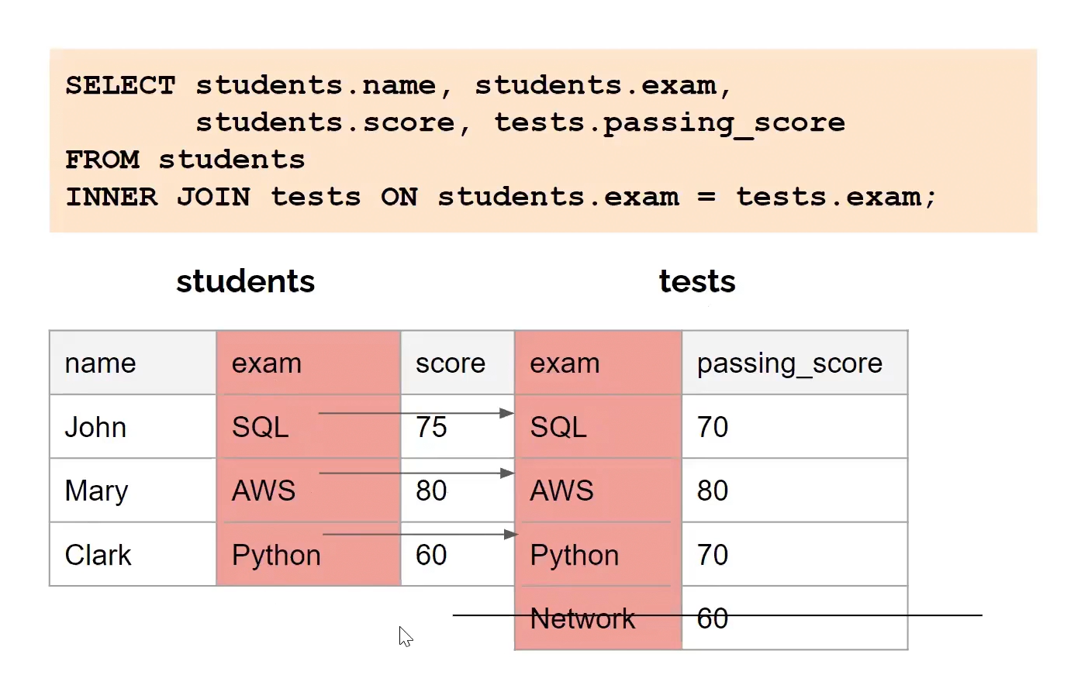

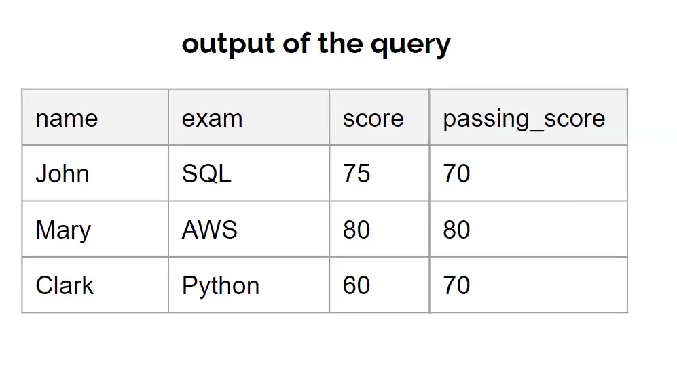

Q: What is inner join?  
A: Retrieves records that have matching values in both tables involved in the join. This is the widely used join for queries.

Example

Suppose you want to join the "employees" table and the "departments" table. In this example, an INNER JOIN has been created that is based on the *emp\_id*columns in the two tables:

"employees" table:

emp\_id first\_name last\_name salary job\_title gender hire\_date

------ ---------- --------- ------ ------------------- -------- ----------

17679 Robert Gilmore 110000 Operations Director Male 2018-09-04

26650 Elvis Ritter 86000 Sales Manager Male 2017-11-24

30840 David Barrow 85000 Data Scientist Male 2019-12-02

49714 Hugo Forester 55000 IT Support Speciali Male 2019-11-22

51821 Linda Foster 95000 Data Scientist Female 2019-04-29

67323 Lisa Wiener 75000 Business Analyst Female 2018-08-09

70950 Rodney Weaver 87000 Project Manager Male 2018-12-20

71329 Gayle Meyer 77000 HR Manager Female 2019-06-28

76589 Jason Christian 99000 Project Manager Male 2019-01-21

97927 Billie Lanning 67000 Web Developer Female 2018-06-25

"departments" table:

emp\_id dept\_name dept\_id

------ -------------- -------

17679 Operations 13

26650 Marketing 14

30840 Operations 13

49823 Technology 12

51821 Operations 13

67323 Marketing 14

71119 Administrative 11

76589 Operations 13

97927 Technology 12

To understand easily how INNER JOIN works, we can use the following visual explanation. The intersection of the two tables represents the matching rows.

**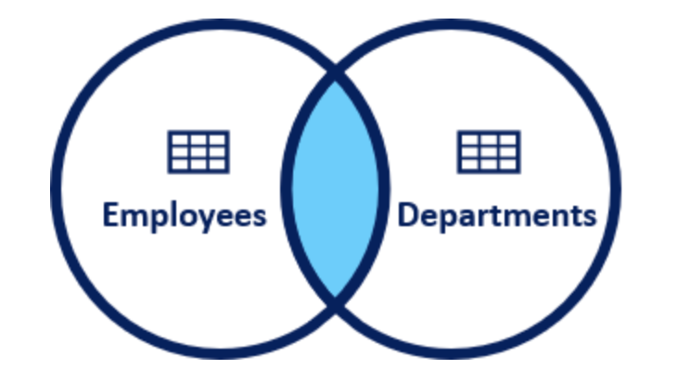**

*Visual Representation of Inner JOIN*

**Syntax**

The INNER JOIN keyword selects all rows from both "employees" and "departments" tables as long as there is a match between the columns. If there are records in the "employees" table that do not have matches in "departments", these records are not shown in the output.

|  |
| --- |
| SELECT  employees.emp\_id,  employees.first\_name,  employees.last\_name,  departments.dept\_name,  departments.dept\_id  FROM employees  INNER JOIN departments  ON employees.emp\_id = departments.emp\_id; |
| emp\_id first\_name last\_name dept\_name dept\_id  ------ ---------- --------- ---------- -------  17679 Robert Gilmore Operations 13  26650 Elvis Ritter Marketing 14  30840 David Barrow Operations 13  51821 Linda Foster Operations 13  67323 Lisa Wiener Marketing 14  76589 Jason Christian Operations 13  97927 Billie Lanning Technology 12 |

As you can see from the output, the seven employees in the "employees" table have matches in the "department" table. The remaining three employees are not listed in the output. As you can see, employee ID 17679 is in both tables and matches, so it is included in our output table. On the other hand, employee ID 49714 is included in the employee table but not in the department table and there is no match. Therefore, employee ID 49714 is not included in the output table.

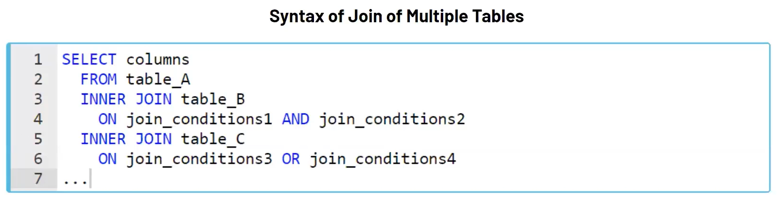

### Left JOIN

In this JOIN statement, all the records of the left table and the common records of the right table are returned in the query. If no matching rows are found in the right table during the JOIN operation, these values are assigned as NULL.

Here is the syntax of the LEFT JOIN clause:

|  |
| --- |
| SELECT columns  FROM table\_A  LEFT JOIN table\_B ON join\_conditions |

In this syntax,

* *columns*: Column names from table\_A or table\_B.
* *table\_A, table\_B*: The names of the joined tables.
* *join\_conditions:* It specifies the conditions to evaluate for each pair of joined rows.

LEFT JOIN and LEFT OUTER JOIN keywords are exactly the same. OUTER keyword is *optional*.

SELECT columns

FROM table\_A

LEFT OUTER JOIN table\_B ON join\_conditions

* If no match is found for a particular row, NULL is returned.

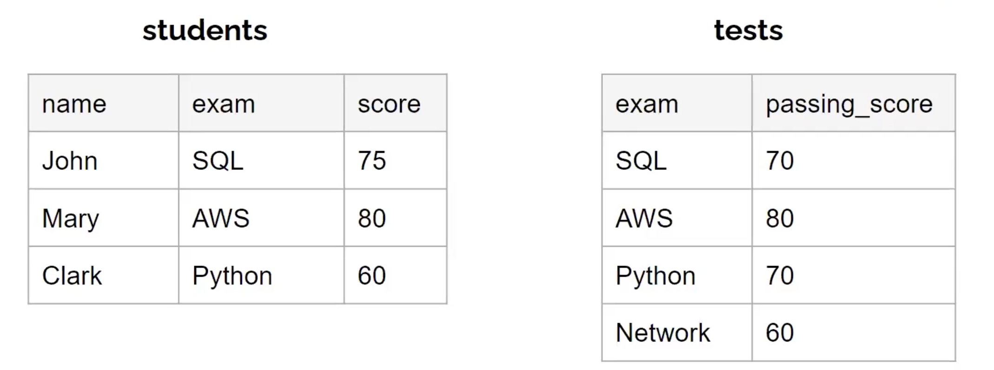

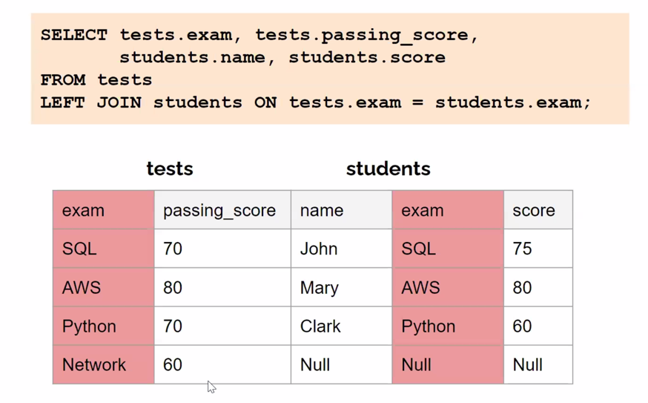

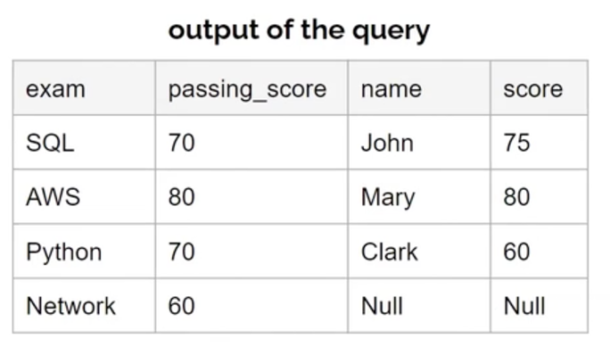

Example

Suppose you want to join the "employees" table and the "departments" table. In this example, a LEFT JOIN has been created that is based on the *emp\_id*columns in the two tables:

"employees" table:

emp\_id first\_name last\_name salary job\_title gender hire\_date

------ ---------- --------- ------ ------------------- -------- ----------

17679 Robert Gilmore 110000 Operations Director Male 2018-09-04

26650 Elvis Ritter 86000 Sales Manager Male 2017-11-24

30840 David Barrow 85000 Data Scientist Male 2019-12-02

49714 Hugo Forester 55000 IT Support Speciali Male 2019-11-22

51821 Linda Foster 95000 Data Scientist Female 2019-04-29

67323 Lisa Wiener 75000 Business Analyst Female 2018-08-09

70950 Rodney Weaver 87000 Project Manager Male 2018-12-20

71329 Gayle Meyer 77000 HR Manager Female 2019-06-28

76589 Jason Christian 99000 Project Manager Male 2019-01-21

97927 Billie Lanning 67000 Web Developer Female 2018-06-25

"departments" table:

emp\_id dept\_name dept\_id

------ -------------- -------

17679 Operations 13

26650 Marketing 14

30840 Operations 13

49823 Technology 12

51821 Operations 13

67323 Marketing 14

71119 Administrative 11

76589 Operations 13

97927 Technology 12

To understand easily how LEFT JOIN works, we can use the following visual explanation. The shaded area represents all rows in the "employees" table and all matching rows in the "departments" table

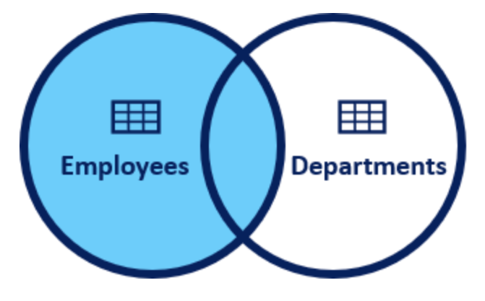

|  |
| --- |
| SELECT  employees.emp\_id,  employees.first\_name,  employees.last\_name,  departments.dept\_name,  departments.dept\_id  FROM employees  LEFT JOIN departments  ON employees.emp\_id = departments.emp\_id; |
| emp\_id first\_name last\_name dept\_name dept\_id  ---------- ---------- ---------- ---------- ----------  17679 Robert Gilmore Operations 13  26650 Elvis Ritter Marketing 14  30840 David Barrow Operations 13  49714 Hugo Forester null null  51821 Linda Foster Operations 13  67323 Lisa Wiener Marketing 14  70950 Rodney Weaver null null  71329 Gayle Meyer null null  76589 Jason Christian Operations 13  97927 Billie Lanning Technology 12 |

As a result of the LEFT JOIN operation, all ten rows are returned from the "employees" table and all matching rows in the "departments" table are returned. The rows that do not match with the right table are returned as null.

# Subquery

A subquery is a SELECT statement that is nested within another statement. The subquery is also called the **inner query** or **nested query**. A subquery may be used in:

* SELECT clause
* FROM clause
* WHERE clause

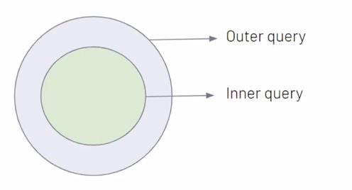

A subquery is usually embedded inside the WHERE clause. You may use comparison operators such as >, <, =, IN, NOT IN with WHERE clause.

Here is the syntax:

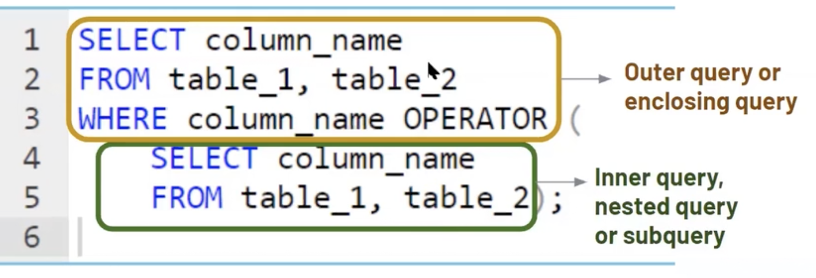

The inner query is executed first before the outer query. The results of the inner query are passed to the outer query.  
  
There are some rules when using subquery:

* A subquery must be enclosed in parentheses.
* An ORDER BY clause is not allowed to use in a subquery.
* The BETWEEN operator can't be used with a subquery. But you can use BETWEEN within the subquery.

Below are some example uses of subqueries:

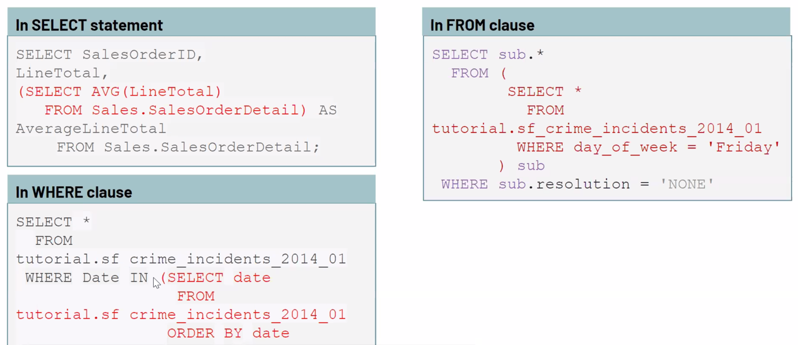

"employees" table:

emp\_id first\_name last\_name salary job\_title gender hire\_date

------ ---------- --------- ------ ------------------- -------- ----------

17679 Robert Gilmore 110000 Operations Director Male 2018-09-04

26650 Elvis Ritter 86000 Sales Manager Male 2017-11-24

30840 David Barrow 85000 Data Scientist Male 2019-12-02

49714 Hugo Forester 55000 IT Support Speciali Male 2019-11-22

51821 Linda Foster 95000 Data Scientist Female 2019-04-29

67323 Lisa Wiener 75000 Business Analyst Female 2018-08-09

70950 Rodney Weaver 87000 Project Manager Male 2018-12-20

71329 Gayle Meyer 77000 HR Manager Female 2019-06-28

76589 Jason Christian 99000 Project Manager Male 2019-01-21

97927 Billie Lanning 67000 Web Developer Female 2018-06-25

We'll find the employees who get paid more than Rodney Weaver. Our query should return first name, last name, and salary info of the employees.

|  |
| --- |
| SELECT first\_name, last\_name, salary  FROM employees  WHERE salary >  (SELECT salary  FROM employees  WHERE first\_name = "Rodney"); |
| first\_name last\_name salary  ---------- ---------- ----------  Robert Gilmore 110000  Linda Foster 95000  Jason Christian 99000 |

* The inner query returns 87000 which is the salary of Rodney and passes this value to the outer query, in particular to the WHERE clause. (WHERE salary > 87000)
* In the outer query, WHERE clause filters the employees whose salary is more than 87000 and returns the first name, last name, and salary info of those.

There are three main types of subqueries:

* Single-row subqueries
* Multiple-row subqueries
* Correlated subqueries\*

Now, let's find out them.  
\* : This type of subquery will not be covered in the course.

Q: What is a Subquery?  
A: A subquery is a query within another query, also known as nested query or inner query . It is used to restrict or enhance the data to be queried by the main query, thus restricting or enhancing the output of the main query respectively.

## Single-Row Subqueries

Single-row subqueries return one row with only one column and are used with single-row operators such as **=**, **>**, **>=**, **<=**, **<>**, **!=**  especially in WHERE clause.

Scalar subquery which returns a single row with one column is an example of single-row subqueries. In the [previous lesson](https://lms.clarusway.com/mod/lesson/view.php?id=3979&pageid=5069" \t "_blank), we have shown you a single-row subquery example by finding Rodney's salary that returns a single row with one column (87000).

"employees" table:

emp\_id first\_name last\_name salary job\_title gender hire\_date

------ ---------- --------- ------ ------------------- -------- ----------

17679 Robert Gilmore 110000 Operations Director Male 2018-09-04

26650 Elvis Ritter 86000 Sales Manager Male 2017-11-24

30840 David Barrow 85000 Data Scientist Male 2019-12-02

49714 Hugo Forester 55000 IT Support Speciali Male 2019-11-22

51821 Linda Foster 95000 Data Scientist Female 2019-04-29

67323 Lisa Wiener 75000 Business Analyst Female 2018-08-09

70950 Rodney Weaver 87000 Project Manager Male 2018-12-20

71329 Gayle Meyer 77000 HR Manager Female 2019-06-28

76589 Jason Christian 99000 Project Manager Male 2019-01-21

97927 Billie Lanning 67000 Web Developer Female 2018-06-25

"departments" table:

emp\_id dept\_name dept\_id

------ -------------- -------

17679 Operations 13

26650 Marketing 14

30840 Operations 13

49823 Technology 12

51821 Operations 13

67323 Marketing 14

71119 Administrative 11

76589 Operations 13

97927 Technology 12

We can also use aggregated functions since it returns a single row with a single column. Now let' s find out the employees who get paid more than the average salary. Our query should return first name, last name, and salary info of the employees.

|  |
| --- |
| SELECT first\_name, last\_name, salary  FROM employees  WHERE salary >  (SELECT AVG(salary)  FROM employees); |
| first\_name last\_name salary  ---------- ---------- ----------  Robert Gilmore 110000  Elvis Ritter 86000  David Barrow 85000  Linda Foster 95000  Rodney Weaver 87000  Jason Christian 99000 |

Let's analyze the query above:

* We've used > operator with WHERE clause.
* The inner query returns the average salary which is 83600 and passes this single value to the outer query.
* Outer query filters those employees and returns those whose salary is more than 83600.

As you see that combining aggregate functions with subqueries, we have more power to answer our analytical questions.

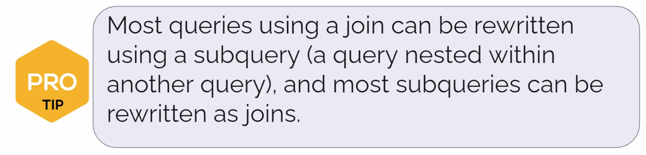

## Multiple-Row Subqueries

Multiple-row subqueries return sets of rows and are used with multiple-row operators such as IN, NOT IN, ANY, ALL.  Now, let's see it in an example.

As you know that we have added a new table to the company database consisting of one table. Our new table is the departments table. It has three columns and nine rows. Every row represents an employee's department info. Here are our database tables.

Now with that said, find the employees (first name, last name from employees table) who work under the Operations department (departments table). Our query should return first name and last name info.

|  |
| --- |
| SELECT first\_name, last\_name  FROM employees  WHERE emp\_id IN  (SELECT emp\_id  FROM departments  WHERE dept\_name = 'Operations'); |
| first\_name last\_name  ---------- ----------  Robert Gilmore  David Barrow  Linda Foster  Jason Christian |

Let's analyze the query above:

* We've used IN operator with WHERE clause.
* The inner query returns the employees ids who work under the Operations department and passes those to the outer query.
* Outer query filters those employees ids and returns their first\_name and last\_name as a result set.

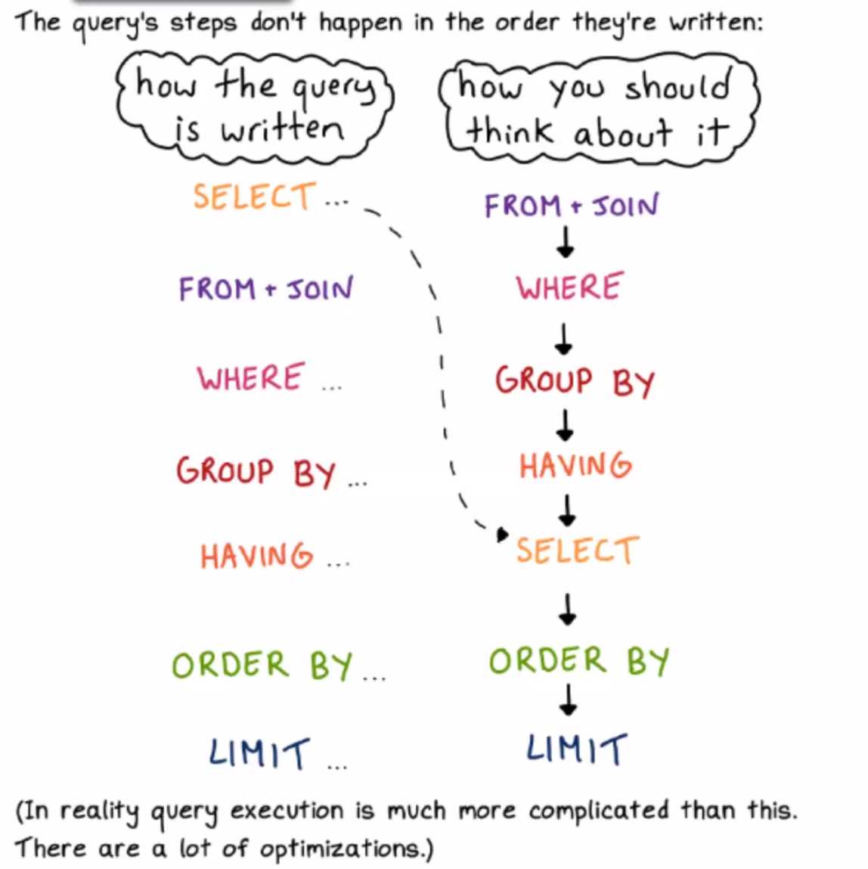

⚠️

When using MIN & MAX you can retrieve different results in SQLite and MySQL. A good practice is to apply SUBQUERY in MySQL to get an accurate result instead of applying JOIN

# DDL Commands

## Introduction

At the beginning of the course, we have mentioned that SQL performs some operations on the database such as retrieval, inserting, updating, creating. Of those, we have seen just SELECT statement for retrieval data operations on the database. As a side note, statements are also called "commands" in some sources.

Actually, these statements are grouped into four main categories:

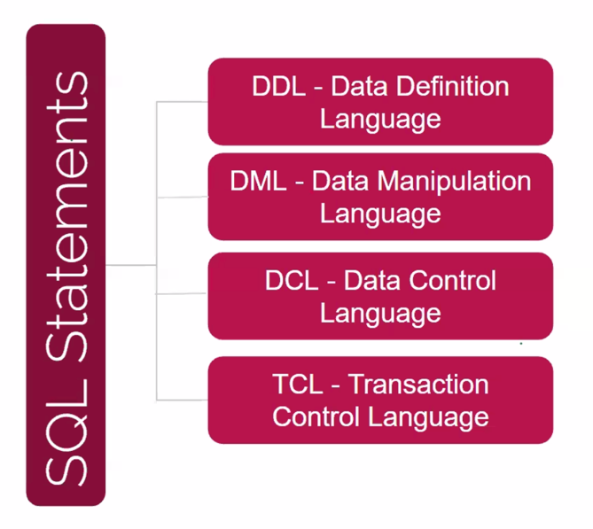

[✱](https://www.toptal.com/designers/htmlarrows/symbols/heavy-asterisk/) Data Definition Language (DDL) specifies the database schema. The statements used in DDL are CREATE, ALTER, DROP. DDL statements are typically used to set up and configure a new database before we insert data.

[✱](https://www.toptal.com/designers/htmlarrows/symbols/heavy-asterisk/) Data Manipulation Language (DML) enables users to access or manipulate data. INSERT, UPDATE, DELETE, SELECT are the statements used in DML.

(In some sources SELECT  statement is groupped into a different category called DQL-Data Query Language)

[✱](https://www.toptal.com/designers/htmlarrows/symbols/heavy-asterisk/) Data Control Language (DCL) is used to grant or revoke access control. Its statements are REVOKE and GRANT.

[✱](https://www.toptal.com/designers/htmlarrows/symbols/heavy-asterisk/) Transaction Control Language (TCL) controls the transactions of DML and DDL commands. Its statements are BEGIN and COMMIT.

DDL, DML, DCL, TCL are not separate languages. They compose parts of a single database language which is SQL. These are for categorical purposes. In this lesson, we'll learn DDL commands. As a side note, we are not going to cover other languages' commands in our course.

Before we dive into the DDL commands, we'll start with data types.

## Data Types

In SQL, data types define what type of data a column can contain or store. Let's find out the data types of the employees' columns. There is a special function typeof in SQLite to display the data types of the values stored in the columns.

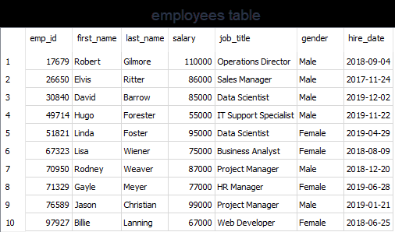

|  |
| --- |
| SELECT typeof(emp\_id),  typeof(first\_name),  typeof(hire\_date)  FROM employees  LIMIT 1; |
| typeof(emp\_id) typeof(first\_name) typeof(hire\_date)  -------------- ------------------ -----------------  integer text text |

As you see that emp\_id stores integer values, first\_name and hire\_date store textual values. Different database systems may use different data types though there are common ones and SQLite is no exception.  
  
In SQLite, there are five primitive **storage classes**. Here are the details of them: (Storage class is not exactly a data type, it’s more inclusive)

* **NULL:**The value is a NULL value. NULL values mean missing information or unknown.
* **INTEGER:**The value is a whole number (positive or negative), stored in 1, 2, 3, 4, 6 or 8 bytes depending on the magnitude of the value.
* **REAL:** The value is a floating-point value, stored as an 8-byte float. They are real numbers with decimal values.
* **TEXT:** The value is a text string, stored using the database encoding (UTF-8, UTF-16BE or UTF-16LE).
* **BLOB:** BLOB stands for a binary large object that can store any kind of data. The value is a blob of data, stored exactly as it was input.

Main data types are:

* + String
  + Date and Time
  + Numeric

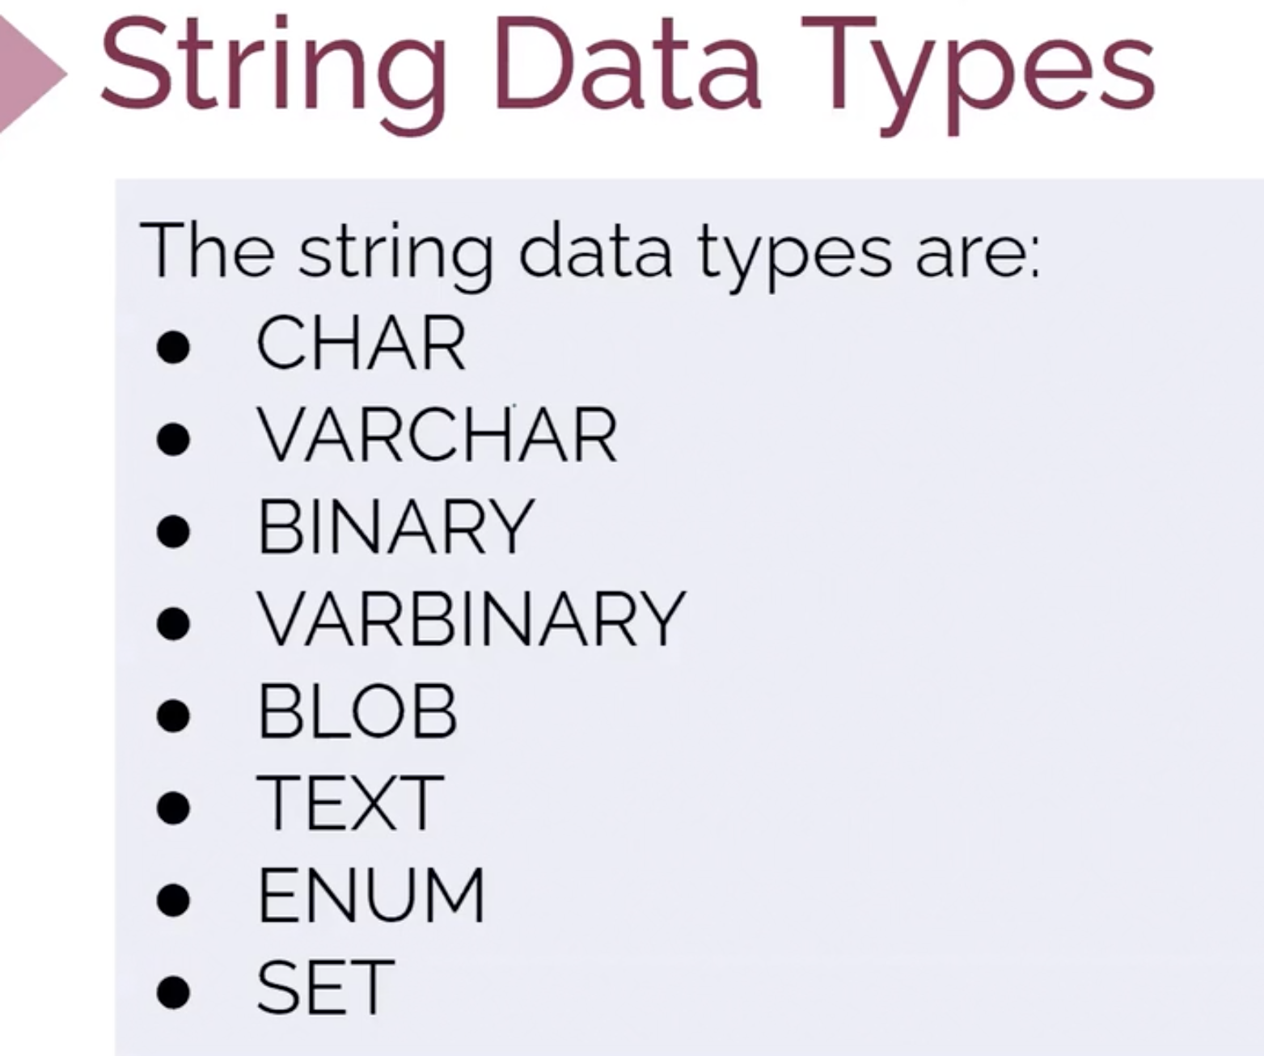

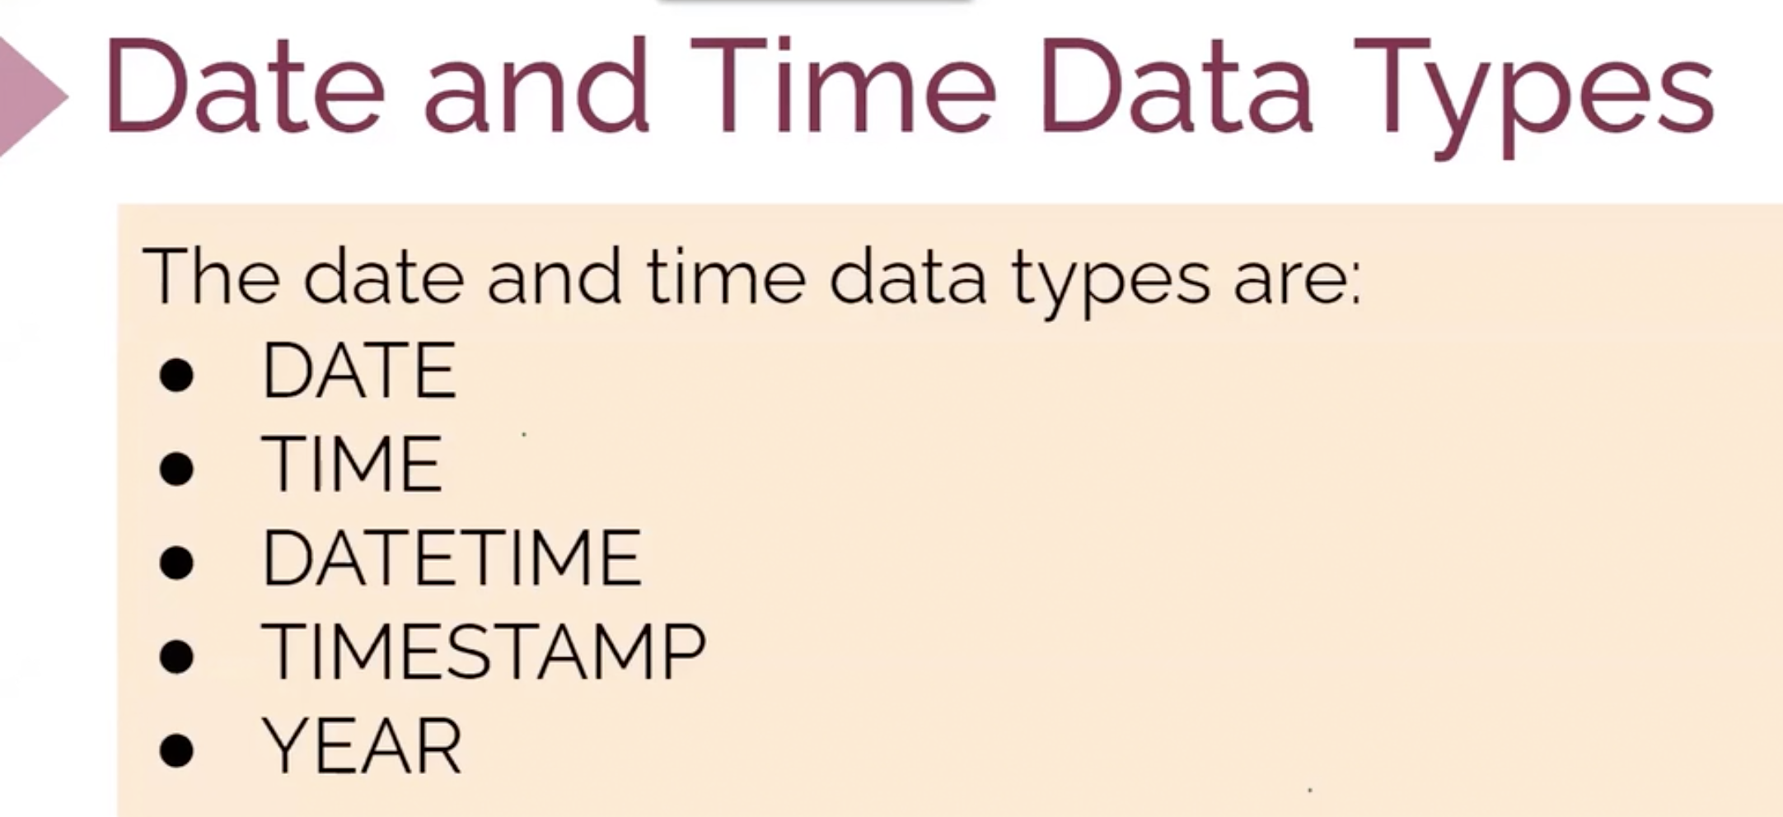

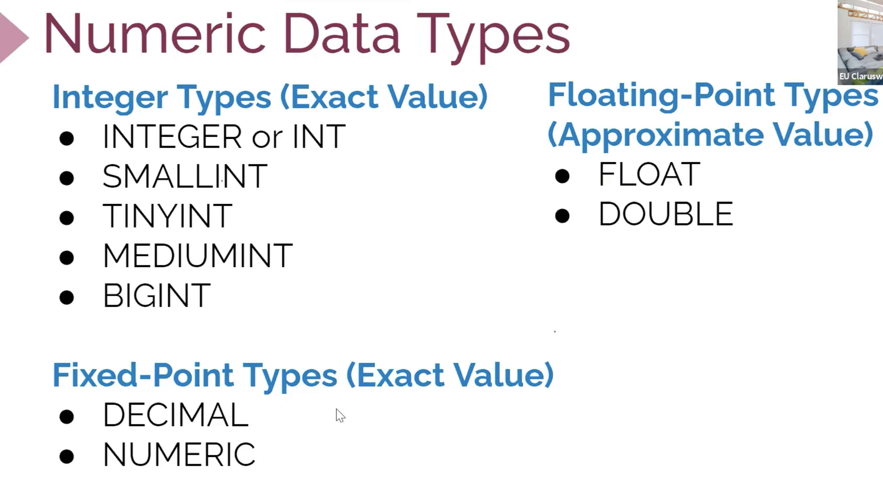

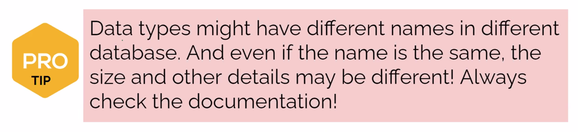

In SQLite, there is no separate Boolean storage class. Boolean values are stored as integers 0 (false) and 1 (true).  
SQLite doesn't have a storage class allocated for dates and/or times. Instead, you use the TEXT, INTEGER, or REAL to store the date and/or time values. 

**💡Tips:**

* A storage class is slightly more general than a data type. For example, the INTEGER storage class covers six different integer data types of different lengths. Most of the part, storage class is indistinguishable from data type and the two terms can be used interchangeably.

SQLite determines the data type of a value based on its data type in accordance with the following rules:  
If a value is enclosed by single or double quotes, it is assigned the TEXT storage class.

* If a value has no enclosing quotes and decimal point or exponent, it is assigned INTEGER storage class.
* If a value has no enclosing quotes, but decimal point or exponent, it is assigned REAL storage class.
* If a value is NULL without quotes, it is assigned NULL storage class.
* If a value has X'ABCD' or x'abcd', it is assigned BLOB storage class.

As we've learned from the previous part, we can use the typeof() function to check the storage class of value based on its format. Let's look at the examples below. As a side note, you don't always need to use FROM table\_name clause if not needed.

|  |
| --- |
| SELECT  typeof('100'),  typeof(100),  typeof(10.0),  typeof(x'1000'),  typeof(NULL); |
| typeof('100') typeof(100) typeof(10.0) typeof(x'1000') typeof(NULL)  ------------- ----------- ------------ --------------- ------------  text integer real blob null |

As you clearly see that the format of the values determines the storage class of the values. You may think that the result of typeof('100') is an integer. But there are enclosed single quotes in 100. Remember the rule that if a value is enclosed with single quote or double quotes, it is stored as text.¨

## CREATE TABLE

In this lesson, we will learn how to create a new table in the database. When creating a table, we use CREATE TABLE statement. Here is the syntax:

|  |
| --- |
| CREATE TABLE database\_name.table\_name (  column1 data\_type,  column2 data\_type,  ...  ); |

A CREATE TABLE statement specifies the following attributes of the new table:

* The name of the new table
* The database in which the new table is created. This is optional. You don't have to specify. For instance, we could have typed CREATE TABLE table\_name (...);
* The name of the columns
* The declared data type of each column

Now, let's create a table in the *students*database. The *students* database has only one table named *student\_table*. If you type the .table command in the playground, the table name(s) of the database will return. .table command is special to SQLite.

|  |
| --- |
| .table |
| Student\_table |

### 

NOTE: Values in VARCHAR columns are variable-length strings. The length can be specified as a value from 0-65365

### Example-1

We will add a table named *teachers*to our students database.Each teacher has the following information:

* Name
* Lesson
* Salary

|  |
| --- |
| CREATE TABLE teachers (  name TEXT,  lesson TEXT,  salary INT  ); |

Now, display the tables in the students database. We must have two tables: student\_table, teachers.

|  |
| --- |
| .table |
| Student\_table teachers |

### Example-2

### 

### 

### Constraints

Constraints are the rules specified for data in a table. We can limit the type of data that will go into a table with the constraints. We can define the constraints with the CREATE TABLE statement or ALTER TABLE statement.

Syntax:

|  |
| --- |
| CREATE TABLE table\_name (  column1 DATATYPE CONSTRAINT,  column2 DATATYPE CONSTRAINT,  ...  ); |

The following are the most commonly used constraints in SQL:

| **Constraint Name** | **Definition** |
| --- | --- |
| NOT NULL | Ensures that a column cannot have a NULL value |
| DEFAULT | Sets a default value for a column when no value is specified |
| UNIQUE | Ensures that all values in a column are different |
| PRIMARY KEY | Uniquely identifies each row in a table |
| FOREIGN KEY | Uniquely identifies a row/record in another table |

Q: What are Constraints in SQL?  
A: **NOT NULL** - Restricts NULL value from being inserted into a column. **DEFAULT** - Automatically assigns a default value if no value has been specified for the field. **UNIQUE** - Ensures unique values to be inserted into the field. **PRIMARY KEY** - Uniquely identifies each record in a table. **FOREIGN KEY** - Ensures referential integrity for a record in another table.

### Primary Key

The primary key is a column in our table that makes each row (aka, record) unique.

**💡 Tips:** The primary key is used to uniquely identify each record

A table can have only one primary key. The primary key can consist of one or multiple columns. We define the PRIMARY KEY in the CREATE TABLE statement.

Syntax

|  |
| --- |
| CREATE TABLE table\_name (  column1 INT PRIMARY KEY,  column2 TEXT,  ...  ); |

It's also possible to define the primary key at the end of the statement. It's very simple syntax: we just say PRIMARY KEY and put the column name inside the parentheses.

|  |
| --- |
| CREATE TABLE table\_name (  column1 INT,  column2 TEXT,  ...  PRIMARY KEY (column\_1)  ); |

We define the primary key to uniquely identify each record. That means the value in the primary key column cannot be repeated. Thus we should choose an appropriate column that meets the criteria of the primary key.  
Let's take the example of employees table. Which column do you think as the best fit for the primary key?



The answer is emp\_id. Because it has no repetition of data and uniquely identifies each record. In this table, each record represents an employee.

The primary key column cannot contain NULL values. You don't get an error when you don't define a primary key in your table. However, good database design starts with a primary key. In fact, our tables in the database need a primary key. That will ensure row-level accessibility. With the primary key, we can query each table row individually.

Suppose that we don't have any tables yet in our company database. Let's create the employees table from scratch and define a primary key.

CREATE TABLE employees(

emp\_id INT NOT NULL PRIMARY KEY,

first\_name TEXT,

last\_name TEXT,

salary INT,

job\_title TEXT,

gender TEXT,

hire\_date TEXT);

You may notice that we use NOT NULL constraint with the primary key. But it's not mandatory to use it with the primary key since the primary key is implicitly NOT NULL.

Q: What is a Primary Key?  
A: The PRIMARY KEY constraint uniquely identifies each row in a table. It must contain UNIQUE values and has an implicit NOT NULL constraint.

### Foreign Key

Foreign key is a column in a table that uniquely identifies each row of another table. That column refers to a primary key of another table. This creates a kind of link between the tables.

Assume that we have a database called *store*. Let's create two tables as customers and orders inside the *store*database.

|  |
| --- |
| CREATE TABLE customers (  customer\_id INT PRIMARY KEY,  first\_name TEXT,  last\_name TEXT  ); |

Now, we will create the second table called *orders.* In the orders table, we defined the FOREIGN KEY for the customer\_id column and pointed it using REFERENCES to the customer\_id column in the *customers* table.

|  |
| --- |
| CREATE TABLE orders (  order\_id INT PRIMARY KEY,  order\_number INT,  customer\_id INT,  FOREIGN KEY (customer\_id)  REFERENCES customers (customer\_id)  ); |

* The customer\_id column in the customers table is the PRIMARY KEY in the customers table.
* The customer\_id column in the orders table is the FOREIGN KEY in the orders table.
* The customers table is called a parent table.
* The orders table is called a child table.

### INSERT INTO

Let's insert some values into our newly created tables. We use INSERT INTO statement to add data. The syntax is very straightforward.

|  |
| --- |
| INSERT INTO table\_name (column1, column2)  VALUES (value1, value2) ; |

We start to enter values to the customers table first.

|  |
| --- |
| INSERT INTO customers (order\_id, order\_number, last\_name)  VALUES (1, “Robert”, “Cursor”),  (2, “Julia”, “Hemnes”),  (3, “Michael”, “Knight”); |

But, what did we achieved by defining FOREIGN KEY? Using foreign keys ensures that not to destroy the links between the tables. Besides, it prevents invalid data entry into the foreign key column. For instance, you cannot add a new customer\_id value to the orders table.

|  |
| --- |
| INSERT INTO customers (order\_id, order\_number, last\_name)  VALUES (5, 105, 4); |

If you run this query, you get a "FOREIGN KEY constraint failed" error. This is also called referential integrity.  Since there is no customer\_id '4' in the customers table, we cannot create a new customer\_id in the orders table.

Q:What is a Foreign Key?  
A: A FOREIGN KEY comprises of single or collection of fields in a table that essentially refer to the PRIMARY KEY in another table. Foreign key constraint ensures referential integrity in the relation between two tables. The table with the foreign key constraint is labelled as the child table, and the table containing the candidate key is labelled as the referenced or parent table.

### Not Null

A column can include NULL values. A NULL value is a special value that means the value is unknown or does not exist. We can specify if a column can hold NULL values or not when we create a table. By default, all columns (except primary key's column) in a table can hold NULL values unless we explicitly specify NOT NULL constraints.

We define NOT NULL constraint for a column using the following syntax:

|  |
| --- |
| CREATE TABLE table\_name (  column\_name type\_name NOT NULL,  ...); |

The NOT NULL constraint follows the type of the column as you see in the syntax.  
Let's give an example. Suppose that order\_number column cannot hold NULL values. That means every order should have an order number.

|  |
| --- |
| CREATE TABLE orders (  order\_id INT PRIMARY KEY,  order\_number INT NOT NULL,  customer\_id INT,  FOREIGN KEY (customer\_id)  REFERENCES customers (customer\_id)  ); |

Let's try to insert a null value to the customer\_id.

|  |
| --- |
| INSERT INTO orders (order\_number)  VALUES (NULL); |

If you run the query, you will get a "NOT NULL constraint failed" error.

## ALTER TABLE & DROP TABLE

### ALTER TABLE Statement

Unlike other database systems, SQLite supports a limited functionality of the ALTER TABLE statement.

With SQLite ALTER TABLE statement, you can perform two operations:

* Rename a table
* Add a new column to a table

#### Renaming a Table:

To rename a table, we use the following ALTER TABLE RENAME TO statement syntax.

|  |
| --- |
| ALTER TABLE existing\_table,  RENAME TO new\_table; |

#### Adding a Column to a Table:

Another operation you can perform with the SQLite ALTER TABLE statement is to add a new column to an existing table. In this case, SQLite appends the new column at the end of the existing columns list.

Here is the syntax of ALTER TABLE ADD COLUMN statement:

|  |
| --- |
| ALTER TABLE table  ADD column\_name column\_definition; |

#### Deleting a Column from a Table:

|  |
| --- |
| ALTER TABLE table  DROP COLUMN column\_name;  --Does not work in SQLite |

#### Modifying a Column from a Table:

|  |
| --- |
| ALTER TABLE table  MODIFY COLUMN column\_name column\_definition;  --Does not work in SQLite |

### DROP TABLE Statement

We use DROP TABLE statement to remove a table in a database. The syntax is very straightforward.

|  |
| --- |
| DROP TABLE table\_name |

Let's remove the *orders* table from the *store* database and show the tables left in the store database.

|  |
| --- |
| DROP TABLE orders  .table; |
| customers |

As you see that we have only one table left in our database. we have successfully removed the *orders* table.